Raising and lowering the parabolic eigenstates of hydrogen

C. E. Burkhardt
St. Louis Community College at Florissant Valley
3400 Pershall Road
St. Louis, MO 63135-1499

J. J. Leventhal
Department of Physics
University of Missouri - St. Louis
St. Louis, MO 63121

Abstract
Application of the angular momentum ladder operators to energy eigenfunctions for any central potential converts the eigenfunction to one having a neighboring value of m, the quantum number associated with the z-component of angular momentum. For the hydrogen atom it is possible to further convert eigenfunctions that result from separation of the Schrödinger equation in spherical coordinates to eigenfunctions having neighboring values of  the quantum number associated with the magnitude of the total angular momentum. In this paper it is shown how to analogously convert hydrogen atom eigenfunctions that result from separation of the Schrödinger equation in parabolic coordinates to eigenfunctions having neighboring values of the parabolic quantum numbers. The derivation is performed using formalism no more sophisticated than that used to derive the properties of the ordinary angular momentum ladder operators in undergraduate quantum mechanics courses.

PACS numbers: 03.65.Ca ; 03.65.Fd ; 03.65.Ge

I. Background
The action of the angular momentum ladder operators on energy eigenfunctions for central potentials is well-known and a subject covered in most introductory quantum mechanics courses. As a result of the spherical symmetry of the potential, the energy eigenvalues are independent of m, the eigenvalue of the z-component of the angular momentum 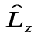. Application of the angular momentum ladder operators, 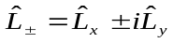, reflect this degeneracy in m by changing it while leaving the principal quantum number n and the total angular momentum quantum number  unaltered. In general, the energy eigenvalues depend upon both n and  so that application of 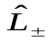 does not shift either of these quantum numbers. For the hydrogen atom, however, there exist additional, but not often studied, ladder operators that shift the values of  (and, in some cases, m as well), but leave n intact[1]. This reflects the super symmetry of the Coulomb potential that is responsible for the celebrated accidental degeneracy of the hydrogen atom in which the energy is independent of  as well as m. By combining the action of both sets of ladder operators it is possible to generate the entire set of eigenfunctions for a given n starting with the  = 0 eigenfunction.

The extra symmetry of the Coulomb potential makes it possible to separate the Schrödinger equation parabolic as well as spherical coordinates. There are thus two sets of hydrogen atom eigenfunctions, the common spherical eigenfunctions which we designate by the ket 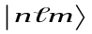, and the parabolic eigenfunctions, 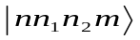. The parabolic quantum numbers are related by
which reduces the number of independent quantum numbers to three as for spherical coordinates. We remark that, traditionally, the absolute value of m occurs in Equation (1)[2]. In the work presented here, however, inclusion of the absolute value of m in Equation (1) precludes proper negative values of m. Indeed, without the absolute value m takes on its proper values 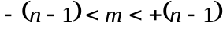.

The quantum number m is the same in both coordinate systems inasmuch as is chosen as one of the mutually commuting operators used to effect the separation in both systems. The operator 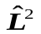, which is one of the mutually commuting operators in spherical coordinates, however, is not used in the parabolic coordinate treatment so these eigenstates are not states of definite angular momentum. They are, however, states having definite z-component of the angular momentum. Since  is not a "good quantum number" in parabolic coordinates it is clear that the usual angular momentum ladder operators cannot be employed to transform one eigenfunction into another. Nonetheless, it is possible to use generalized angular momentum algebra for this purpose as will be demonstrated in this paper. Moreover, the methods used are no more sophisticated than those employed in introductory quantum mechanics courses when introducing the common angular momentum ladder operators.

II. Formalism
We begin by noting that the super symmetry of the Coulomb (or Kepler) potential manifests itself classically as an additional constant of the motion, that is, in addition to energy and angular momentum. This constant is known by several names, but we adopt the appellation "Lenz vector" for simplicity. Of course, this constant of the motion must correspond to a quantum mechanical operator that commutes with the Hamiltonian 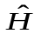. This operator was first introduced by Pauli[3]. In atomic units for which the mass of the electron, the electronic charge and  are all set to unity, the Lenz vector operator is
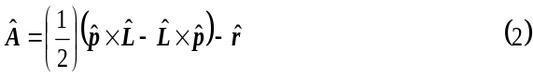
As defined above, 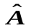does indeed commute with . Moreover, it is Hermetian, as it must be since it represents an observable quantity. A number of relations between and the other relevant operators are listed in Table I. Notice that 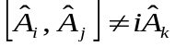 as it would if were truly an "angular momentum". Pauli showed in his brilliant 1926 paper that by scaling and forming linear combinations with 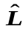 an angular momentum could be constructed. Moreover, these operators provide a means of obtaining the energy eigenvalues, 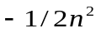 in atomic units. We perform this derivation[4] because some of the results are crucial to the development of the ladder operators that are the main focus of this paper.

We begin by defining an operator 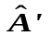 as
Since this operator is to operate only on eigenfunctions of the hydrogen atom 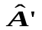 may be written
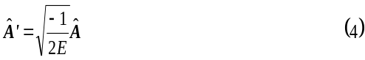
where E is the (unknown) energy eigenvalue. The commutators involving are
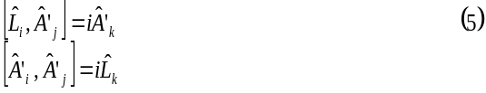
Now define two new operators 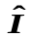 and 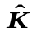as
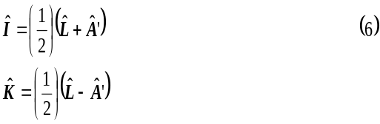
Using the commutation relations above we find that
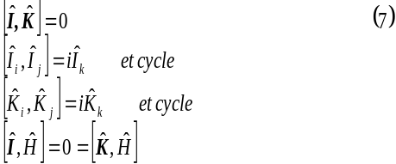
It is seen that and each obey the commutation rule that is the very definition of an "angular momentum". Therefore, the eigenvalues of 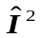 and 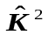 are (in atomic units)
where i and k are quantum numbers that can take on only the values
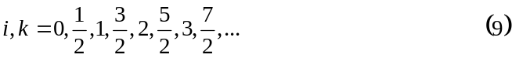
We choose 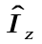 and 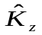 as the components that commute with and and designate their quantum numbers as 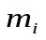 and 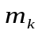. The eigenfunctions of 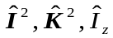 and may thus be designated 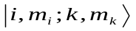. Since they consist of two independent angular momenta it is clear that these kets represent uncoupled angular momenta. Although the quantum numbers appear to be different, the must be the parabolic eigenfunctions because they are not states of definite total angular momentum as are the spherical eigenfunctions. Moreover, the mutually commuting operators that spawned them contain the Lenz vector operator, an operator that was not included (or needed) in the spherical coordinate treatment. These uncoupled eigenfunctions are, of course, also eigenfunctions of the Hamiltonian so the quantum number n is implicit in them. This relationship will now be derived.

Squaring and gives
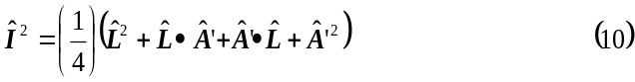
and
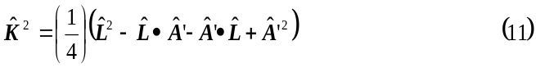
But, 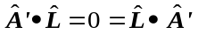 so that
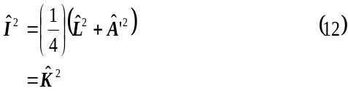
Therefore, i = k and
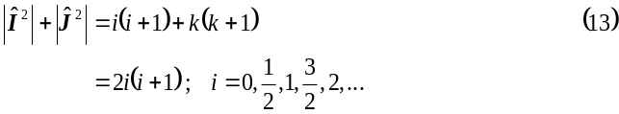
In terms of the modified Lenz vector 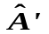 the relationship between 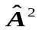, 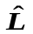 and 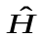 is (see Table I)
Since, however
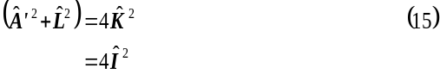
we have
Applying this operator to one of the which we condense to 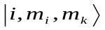 we have
because is an eigenfunction of all operators in Equation (16). Solving Equation (17) for E we have
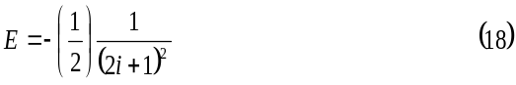
Now, (2i + 1) must be an integer because i can take on all positive half-integral and integral values. Therefore, 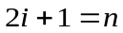, where n = 1, 2, 3, ... Of course, n is the principal quantum number and
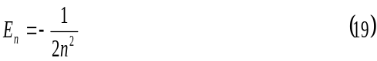
which is the correct eigenvalue in atomic units.

To derive the forms and actions of the ladder operators we use two of the results of the derivation of the energy, i = k and 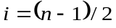. Because and are angular momenta we know the forms and actions of their ladder operators. Since they are identical we work only with the operator 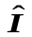. We have
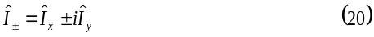
Application of these operators produces the following action

Clearly then, to use this formalism to convert the into another parabolic eigenfunction it is necessary to find the relationship between the apparently different sets of quantum numbers. First, we note that because 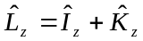
Noting the symmetry between n₁ and n₂ and between m_{i} and m_{k} we may write, using Equation (1)
Of course, we could have used any combination of n₁, n₂ and m_{i} and m_{k}. Equation (23) leads to the desired relationships
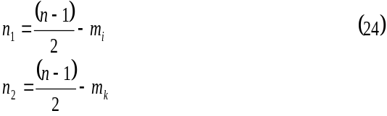
where the n₂ equation follows by symmetry. We know that 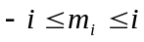 and, from the derivation of the energy eigenvalues we know that . Therefore,
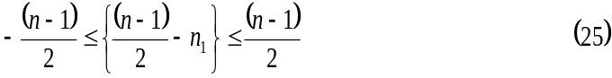
from which we find that
and, of course,

Now, to investigate the action of the ladder operators we choose to examine application of 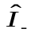 to to obtain
Noting from Equation (24) that lowering m_{i} while keeping n constant in fact raises n₁, we may cast Equation (28) in terms of n, n₁ and n₂.
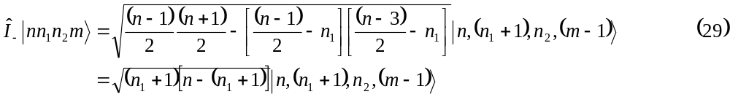
For clarity we have continued to include the magnetic quantum number m in the eigenkets although, by Equation (1), it is redundant.

By symmetry we write
Note that if n₁ or n₂ has its maximum value, n-1, then application of or 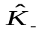 annihilates this ket. To lower n₁ or n₂ it is necessary to raise m_{i} or m_{k}. We obtain for 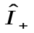
with analogous equation for the application of 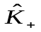.
III. Generation of a manifold of parabolic states
Generation of a set of parabolic states from one of the set is merely a matter of judiciously applying the raising and lowering operators 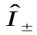 and 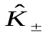. For example, suppose we know the parabolic eigenstate 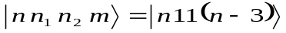. If we successively apply and we obtain
Applying to the original 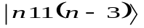 we have
Clearly successive applications of these operators can generate the entire manifold of parabolic states for a given n.
IV. The action of 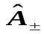, 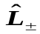 and 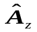 on parabolic eigenfunctions.
By noting that
and
the actions of these operators on a parabolic eigenstate may be obtained. For example, applying 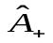 to an arbitrary parabolic ket we have
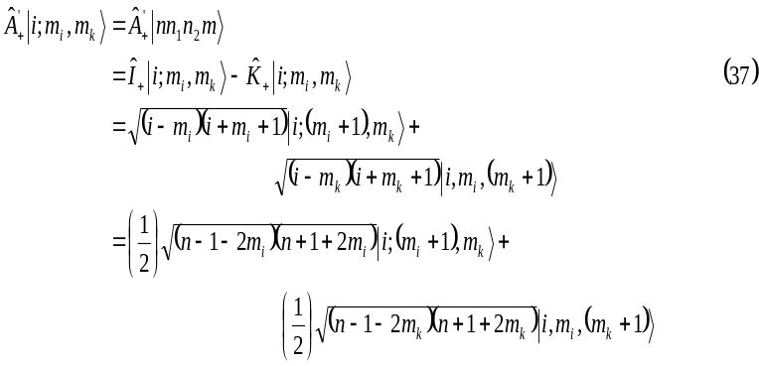
It is common in the parabolic coordinate description[5] to combine quantum numbers and define 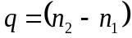. This is referred to as the electric quantum number because the parabolic eigenfunctions are also eigenfunctions when the hydrogen atom is subjected to a constant electric field. Together with Equation (22) then the action of on a parabolic eigenket is
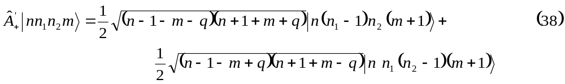
Similarly, for the other three operators we obtain
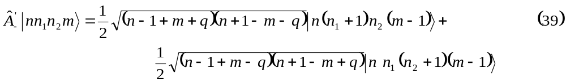
and
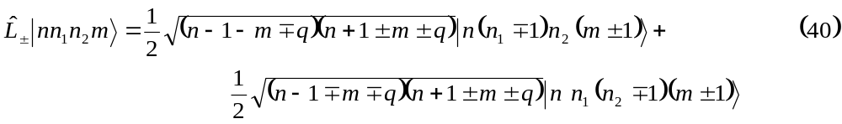

In addition to the above results we may also find the action of 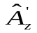, and thus 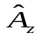, on parabolic eigenfuntions. We have
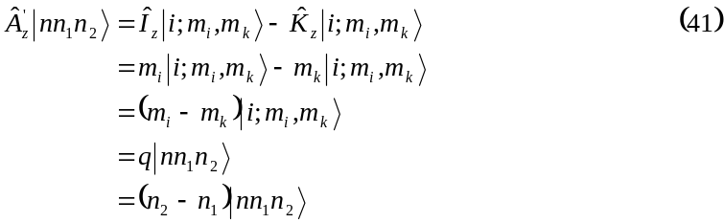
Thus, parabolic eigenfunctions are eigenfunctions of 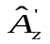 with eigenvalues q. The observable thus has possible values 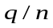. Clearly then, the commuting operators employed when solving the hydrogen atom problem in parabolic coordinates are , 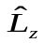 and .

V. Generation of Clebsch-Gordan coefficients.
Since the spherical eigenfunctions and the parabolic eigenfunctions each constitute a complete set it is possible to expand an eigenfunction of one set as a linear combination of the other. As noted previously, the parabolic states, in effect, contain two uncoupled angular momenta, 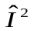 and 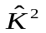 while the spherical states are states of coupled angular momenta. Thus, the expansion of an eigenfunction of one set in terms of eigenfunctions of the other set requires the Clebsch-Gordan coefficients[6]. Using the formalism developed here it is possible, in some cases, to obtain these coefficients. Of course, the tables of Clebsch-Gordan coefficients are more useful for this purpose, but performing the expansion using the formalism developed here can provide useful insight.

As an example we begin with one of the states that are the same in either coordinate system. These are
where subscripts have been added to the kets for clarity. Equation (42) holds m is a good quantum number in both coordinate systems so for the kets to be the same they must have the same value of m. For the case in which 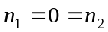 we have only 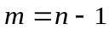. But for, , its maximum value, , must have its maximum value, that is, 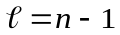. Thus, there is only one state in each basis set that has a maximum (or minimum) value of m.

We apply 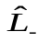 to the spherical eigenfunction and in the form 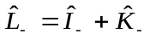 to the parabolic eigenfunction and obtain
and
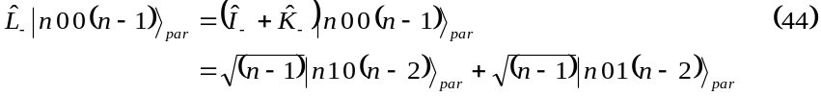
so that
Successive application of will generate the entire set of spherical eigenfunctions for 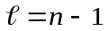. Other Clebsch-Gordan coefficients can be obtained, but with considerably more labor and are thus not within the scope of the work presented here.
REFERENCES
1. C. E. Burkhardt and J. J. Leventhal, "A complete set of ladder operators for the hydrogen atom," Am. J. Phys. (submitted).
2. H. A. Bethe and E. E. Salpeter, Quantum Mechanics of One- and Two-Electron Atoms (Springer-Verlag; Berlin; 1957). pp 228-232.
3. W. Pauli, "On the Hydrogen Spectrum from the Standpoint of the New Quantum Mechanics"
The English translation is in: Sources of Quantum Mechanics edited by B. L.d Van Der Waerden (Dover; New York; 1967) pp 387 - 415.
4. L. I. Schiff, Quantum Mechanics (McGraw-Hill; New York; third edition; 1968). P 234.
5. L. C. Biedenharn, J. D. Louck and P. A. Carruthers, Angular Momentum in Quantum Mechanics: Theory and Application (Addison-Wesley; Reading, MA; 1981). Pp 335 – 344.
6. D Park, "Relation between the parabolic and spherical eigenfunctions of hydrogen," Z. Phys. 159, 155 – 157 (1960).

Table I. List of some relations involving the quantum mechanical operators used in this work.

